Dr. James E. McCoy  
 Superintendent  
334-705-6000  
Fax: 334-745-9822

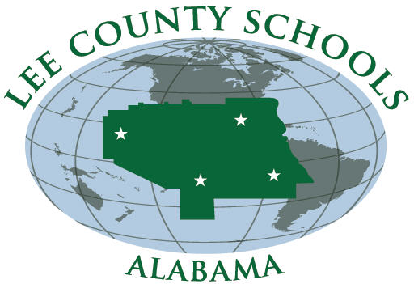

Lee County Board of Education  
2410 Society Hill Road  
Opelika, AL 36804-4830

***A Tradition of Excellence – A Vision for Tomorrow***

SCHOOLWIDE AUTHORITY & COMPLAINT PROCESS

All schools in Lee County operate Title I School-wide Programs. These programs provide all students who attend schools within the school district the same access to all programs for which they qualify. Instructional services are not limited to low-performing, low income students. Therefore, the Lee County School System welcomes input from all of its parents in the development, implementation, and evaluation of its LEA Consolidated Plan. Parents are asked to take a few minutes to read the district’s LEA Consolidated Plan which is available in the Federal Programs section of the county’s webpage. Parents can review the ACIP for their children’s school on the appropriate school’s webpage.

Parent concerns regarding an individual school’s CIP, the school’s use of its portion of the 1% set aside for parental involvement activities, the school district’s LEA Consolidated Plan I Plan, district’s use of its portion of the 1% set aside for parental involvement activities, and/or the district’s Parental Involvement plan should follow the established complaint process.

 Those in disagreement should first contact their respective school administrator to submit their written concern(s) and suggestion(s) for resolution. If the matter is not resolved at the school level, the principal will refer the parent to the district’s Federal Programs Director, Dr. Brad Hunter. In the event the matter cannot be settled at the district level, the parent’s written concern(s) and suggestion(s) for resolution will be submitted to the State Department of Education Federal Programs Section via the local Federal Programs Director.